School Administrators as Leaders of Teaching and Learning Practice

Yi Chen

Teachers College, Columbia University

Refection Two for Research, Theory, and Practice in Education Leadership

Abstract

*Abstract*: The goal of this reflection paper is two-folded. For the first part, I will start with discussing the relationship between educational leadership, administration and management. Some critical terminologies and concept about educational leadership in teaching and learning practice will be clarified. (mainly based on the perspective from Chapter Three and Four in Firestone & Riehl, 2005) Meanwhile, I will discuss how educational leadership theory evolve overtime. For the second part, I will discuss my reflection about using big data techniques (e.g., text mining) in education leadership research (mainly based on the idea from Wang & Bowers, 2016).

Keywords: Teaching, Learning, Administration, Text Mining

School Administrators as Leaders of Teaching and Learning Practice

# Comprehension

In last week, we discuss the relationship between educational leadership and educational management. Unfortunately, difference between leadership and management is not just semantic. The complex reality of education usually requires the principal to plays the role both as manager (focus on past and stability) and leader (focus on the future and potentials) under different situations. In this week, there is new terminology frequently appear: educational administration. According to the opinion from Dimmock (1995), leadership is the decision-making of **high-level** tasks in order to achieve a balance, aiming at improving the abilities of employees and students and the level of running schools; management is the development of **routine** work; administration is the management of **low-level** affairs. As Leaders in school, all of these three skills are required. And the ultimate target is the improvement of teaching, thinking, and eventually learning.

Based on my understanding about the topic in this weeks’ reading, I think there are three core problems. Here, I provide some additional studies and try to give the answers.

* The leadership effect on learning

Kenneth et al. (2004) summarized that there are three sets of practice make up the basic core of educational leadership practice: setting directions, developing people, and redesigning the organization (instructional leadership perspective). Beyond that, leader in school should also master productive responses to the unique demands of the context (e.g., organization context, student population, and policy context). This idea is strongly against the Socrates’ philosophy that leadership is context independent and transferable.

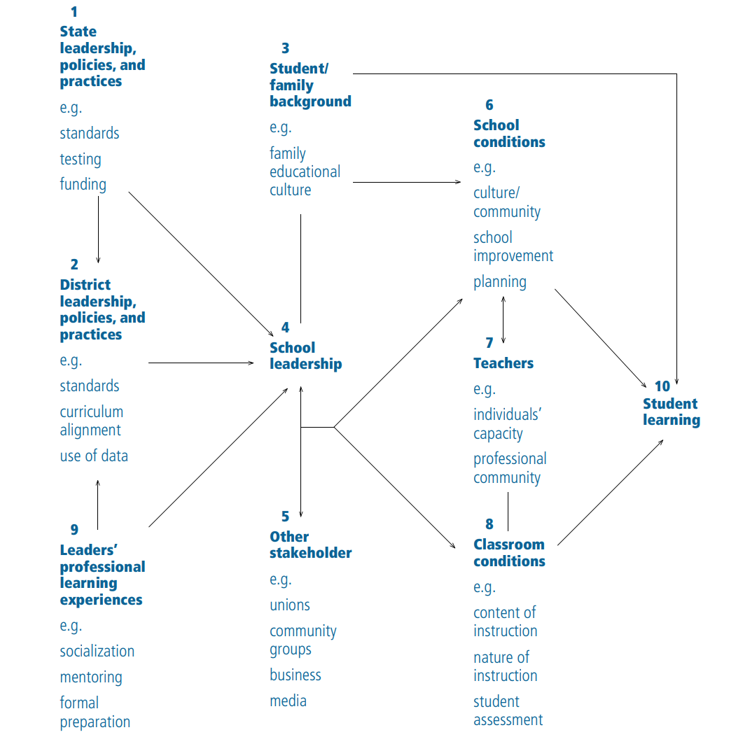

Figure 1. Linking Leadership to Learning

* Mediated and moderated effects of leadership in learning

Figure 1 indicates that school leadership plays critical role in supporting learning. This plot is based on the research framework from Kenneth et al. (2004). It is hard to clarify what are the mediator or moderators between leadership and learning. For my perspective, the mediator mainly is identifying and supporting learning. These effects influence the classroom environment, teachers’ practice, and school condition, which directly play a role in student learning. For example, when the principal emphasis the importance of social interaction in teaching. Teachers may be encouraged to apply more project-based learning in classroom. Structuring the social setting and mediating external demands is the moderators.

* Helping teachers learn: adult development and professional growth in schools

Susan (2004) provided a new model of learning-oriented school. In this study, the principals employ four mutually reinforcing initiatives: teaming/partnering with college within and outside the school, providing teachers with leadership roles, engaging in collegial inquiry, and mentoring. As professional developer and educator, school leaders employ adult developmental principles to support teacher learning.

# Evaluation

There are many theories appear in this week’s reading, including instructional leadership, distributed leadership, and community leadership. In this section, I will provide the definitions of these theories based on the history of research in educational leadership.

The traditional educational leadership research (first half of the 20th century) is based on *characteristic models*. Similar to Socrates, good school leaders should possess certain characteristics: intelligence, academic ability, responsibility, social participation, cognitive ability, motivation, vision, and so on (Stogdill, 1948; Mann, 1959; Zaccaro 2004). As we have mentioned before, this concept mainly has three drawbacks: lack of consideration in unique context, ignoring the developmental value of leaders and analyzing leadership in a static perspective.

In 1940s to earlier 1960s, researchers focused on *behavioral theories of leadership*. These studies consider the observable actions and reactions of leaders and followers in a given situation (Bales, 1951; Blake, 1964). Different from the characteristic’s models, behavioral theories concentrate on what leaders actually do rather than their qualities. And researchers observed and categorized different leadership style.

In 1960s, *contingency models* became popular. The model states that there is no one best style of leadership. Instead, a leader's effectiveness is based on the situation. This is the result of two factors: leadership style and situational favorableness (Fiedler, 1978).

In 1960s to 1970s, more and more research focused on *cognitive resource theory*. This leadership theory is a reconceptualization of Fiedler contingency model. The theory focuses on the influence of the leader's [intelligence](https://en.wikipedia.org/wiki/Intelligence) and experience on their reaction to [stress](https://en.wikipedia.org/wiki/Stress_(medicine)).

The effective school movement in 1980s lead to the popularity of *instructional Leadership*. Researchers focused on understanding the principals’ role to running successful schools. Different from the previous theories, this theory is mostly in the educational context.

Hallinger and Murphy's (1985) proposed the key role of instructional leaders in three dimensions: 1) Defining the school mission, 2) Managing the instructional program, and 3) Promoting a positive school-learning climate.

In 1990s, instructional leadership has been criticized for focusing too much on the individual principal’s heroic role. Thus, researcher started focusing on the shared and distributed nature of educational leadership from broader perspectives. *Transformational leadership*, *shared leadership*, and *distributed leadership* becomes increasingly popular.

1. *Transformational leadership* emphasis that leaders work with teams to identify needed change, creating a vision to guide the change through inspiration, and executing the change in tandem with committed members of group. This theory focus on improving the motivation, morale, and performance of the followers in a collaborative way.
2. *Distributed leadership* foreground how actors engage in tasks that are stretched or distributed across the organization. These theory focus on social process at the interaction of leaders, followers, and the situations.

# Application

In this section, I will briefly discuss my thinking about the social network analysis on scholarly resource. As a data science researcher in an academic library of a graduate school of education, I get the chance to access to various scholarly resources (mainly digital) and analysis them with social network analysis. Based on my personal research experience, the utilization of big data techniques is powerful while still limited.

Firstly, big data we have is not perfect or big enough in most cases. The data used in Wang (2016) is journal citation network. My concerns about this data set is how representative it is? As it claims in the paper that 5359 journals and 157372 citations. However, I find some journals that are not necessary directly related to educational administration. For example, the topic of Teachers College Records (one selected journal) evolves overtime, and recently it accepted more paper about educational technologies. If we include all of these papers under the category of educational administration, the result will still be related but not strong (All related to education but not necessary focus on administration). If we just pick the article directly related to administration (e.g., the title much include ‘administration’ or some other key words), there may not be enough network data to provide insightful results. Alternative approach is to identify the topic of each paper and only select the paper that really related to educational administration. But auto-tagging (or auto subject classification) is also very challenging text mining technique. In particular, how we can define the characteristic of educational administration? It comes back to the dilemma that we face in the last class about the difference between educational leadership and educational management.

Even the data set is reliable, can we really identify the research trend through the network analysis. As what is mentioned in the paper, this analysis is static rather than dynamic analysis (to make it dynamic, the simplest way maybe just repeating the research condition on different publish years). Besides, whether the citation can measure the scholarly impact is also an open question. Despite the popularity of this measurement, it is to some extent slow (Brody, Harnad, & Carr, 2006), narrow (Priem & Hemminger, 2010), secretive as well as irreproducible (Rossner, Van Epps, & Hill, 2008), open to gaming (e.g., self-citation; Falagas & Alexiou, 2008), and based at the journal level rather than the article level (Meho, 2007).

Finally, most of the big data is more descriptive than interpretative. Social network analysis does provide a beautiful technique to visualize interaction. Measurements like Freeman indegree and betweenness, mainly provides a descriptive summary of the density of network at different position. Additionally, most text mining techniques focus on content data while ignore the user behavior (e.g., how many times these articles or journals been read, download, and shared). Thus, much bigger community of learners are ignored. The results are more about describe the current status of published paper rather than really uncover the truth about how researchers do reach, how these research influence the practice, or how it influence learning and teaching in reality.

References

Dimmock, C. (1995). Principals and School Restructuring: Conceptualizing Challenges and Dilemmas. Journal of Educational Administration, 441-462.

Leithwood, K., Seashore K., Anderson S., & Wahlstrom K., Center for Applied Research and Educational Improvement Report (2004). *How Leadership Influences Student Learning*, Retrieved from <https://www.wallacefoundation.org/knowledge-center/Documents/How-Leadership-Influences-Student-Learning.pdf>

Susan M. J., (2004) *Helping Teachers Learn: Principal Leadership for Adult Growth and Development*, Oaks, California: Corwin Press

Stogdill, R. R. (1948). Personal Factors associated with leadership: A survey of the literature. *The Journal of psychology*, 25: 35-71

Mann, R. D. (1959). A Review of the Leadership between Personality and Performance in Samll Group, *Psychological Bulletin*. 56

Zaccaro, S. J., Kemp, C., & Bader, P. (2004). *Leader traits and attributes*. In Antonakis, J., Cianciolo, A. T., & Sternberg, R. J. (eds.), *The Nature of Leadership*, Sage, Thousand Oaks, CA, pp. 101-124.

Bales, R. F. (1951). *Interaction process analysis: A method for the study of small groups*. Addison-Wesley, Reading, MA.

Blake, R. R., & Mouton, J. S. (1964). *The Managerial Grid*, Gulf Publishing Group, Houston. Fiedler, F. E. (1978). The contingency model and the dynamics of the leadership process. In Bekowitz, L. (ed.), *Advances in Experimental Social Psychology*, Vol. 11, Academic Press, New York, pp 59-112.

Hallinger, P., & Murpht, J. (1985). Assessing the instructional leadership behavior of principals. *Elementary School Journal*, 86(2), 217-24

Wang. Y., & Bowers, A. J. (2016). Mapping the Field of Educational Administration Research: A Journal Citation Network Analysis of the Discipline. *Journal of Educational Administration*. 54(3), 242-269.

Brody, T., Harnad, S., & Carr, L. (2006). Earlier web usage statistics as predictors of later citation impact. *Journal of the American Society for Information Science and Technology*. doi:

10.1002/asi.20373

Priem, J., & Hemminger, B. M. (2010). Scientometrics 2.0: Toward new metrics of scholarly impact on the social Web*. First Monday*

Rossner, M., Van Epps, H., & Hill, E. (2008). Irreproducible results: A response to Thomson

Scientific. *Journal of Cell Biology*. doi: 10.1083/jcb.200801036

Falagas, M. E., & Alexiou, V. G. (2008). The top-ten in journal impact factor manipulation. doi:

10.1007/s00005-008-0024-5